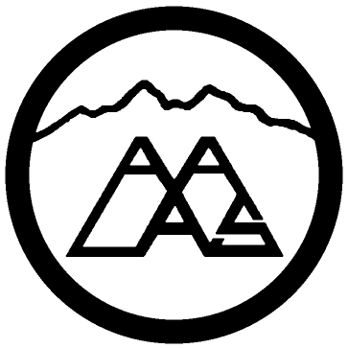 Mile High Branch AALAS, Inc.

MHB honorary membership Award
1 Year Free membership offered to any individual within the Mile High Branch geographical area (Colorado/Wyoming) who successfully passed any level of certification examination during the year immediately preceding the current membership year.
The current annual membership dues would be waived in recognition of certification achievement. This honorary membership is valid for one year only.

Please complete the following fields and attach a copy of your exam certificate, and submit to: Samantha Bozan: SAMANTHA.BOZAN@UCDENVER.EDU
Certification level and date passed:
ALAT _____________
LAT _______________
LATG ______________
CMAR _______________
Name: ___________________________________________________________

Job Title: _________________________________________________________

Employer: ________________________________________________________

Employer Address: ____________________________________________________________________________________

Email: ____________________________________________________________________________________

Mile High Branch Member? _________
AALAS Member? ___________

